Requirements Analysis Document for MentorWeb

# CMPE/SE 133

# Computer/Software Engineering II

**In Response to MyCareerGym RFP NO.** 1001

**Version 3.0**

**May 9th, 2013**

**Globus**

Dhruv Mevada

Luis Barreto

Miguel Gonzalez

Shruti Padmanabhan

Zohaib Khan

1. Revision History Page 2
2. Introduction Page 2
   1. Purpose of the system Page 2
   2. Scope of the system Page 2
   3. Objectives and success criteria of the project Page 3
   4. References Page 3
   5. Overview Page 3
3. Current System Page 3
4. Proposed System Page 4
   1. *Overview* Page 4
   2. *Functional Requirements* Page 4
   3. *Non-functional Requirements* Page 9
   4. *System Models Page 11*
      1. *Scenarios Page 11*
      2. *Use Cases Page 17*
      3. *Use Case Diagram Page 21*
      4. *Object Model Page 22*
      5. *Dynamic Models Page 23*
         1. *Sequence Diagram Page 23*
         2. *State Machine Diagram Page 31*
         3. *Activity Diagram Page 32*
   5. *User Interface Page 35*
      1. *Screen Mockups Page 35*
      2. *Navigational Paths Page 38*
5. Glossary Page 39
6. Appendices Page 39
   1. *Hardware Requirements* Page 39
   2. *Project Plan* Page 39
   3. *Team Staffing* Page 40
   4. *Team Globus Log* Page 40
7. Index Page 43

0. Revision history

|  |  |  |  |
| --- | --- | --- | --- |
| Version | Authors | Edits/Additions | Notes |
| 1.0 | Zohaib Khan  Miguel Gonzalez, Shruti Padmanabhan  Luis Barreto  Dhruv Mevada | Introduction  Current System  Proposed System  Glossary  Appendices  Index | Initial document |
| 2.0 | Zohaib Khan  Miguel Gonzalez, Shruti Padmanabhan  Luis Barreto  Dhruv Mevada | Introduction(Edit)  Current System(Edit)  Proposed System(Edit)  Glossary(Edit)  Appendices(Edit)  Index(Edit)  System Models(Addition) | Second version. Corrections and System models |
| 3.0 | Luis Barreto  Dhruv Mevada  Miguel Gonzalez  Shruti Padmanabhan Zohaib Khan |  | Third version, updates to use cases, and implementation |

1. Introduction

# 1.1 Purpose of the system

This is a proposal for My Career Gym and stakeholders thereof- including company executives, system architects, system developers and others in affiliation with the MentorWeb project. MentorWeb will provide a platform for professionals to develop their careers through the help of mentors. This proposal will include the basic functionality that My Career Gym is seeking for the first version of MentorWeb.

# 1.2 Scope of the system

MentorWeb will be a website that will allow users to provide mentorship to those seeking it and support to those seeking assistance. With the features of MentorWeb, mentors will have all the tools necessary in providing guidance to their mentee. The first version of MentorWeb will provide the basic features that a free membership will include such as a matchmaking, chat, forum, and rating feature. A well designed matchmaking component will be created in order to provide the most effective relationships.

# 1.3 Objectives and success criteria of the project

In order for this project to be considered a success, Globus expects to create a fully functional website that will have all the necessary features to assist in mentorship. The two main goals will be able to create a well-designed matching system to pair mentors and mentees and to collect quality data to monitor growth of users. Measurements of online vs. offline communication, growth of users, and feedback from users will confirm success of project.

# 1.4 References

The references that were used for the creation of the Requirements Analysis Document (RAD) are Object-Oriented Software Engineering section 4.5.3, and the website studentmentor.org.

# 1.5 Overview

MentorWeb is a web-application that is designed to support a mentor-mentee relationship in a field of the mentee’s choice. The mentors are professionals who are in the industry, and the main purpose of MentorWeb is to provide guidance and direction to mentees who seek to gain deeper skills to be more competitive in the job-market, those who are just interesting in learning more about a particular field, or anyone else who has an interest in developing their skills in a particular field. MentorWeb is not, however, aimed for college students, and is specifically geared towards those who are working in the industry, wanting to change their professions.

MentorWeb functions on the basis of providing a mentor to a mentee, and comes with embedded software to support mentor-mentee facilitation and interaction. There are also opportunities for mentees to collaborate with each other via forums in each mentee’s respective fields.

2. Current system

The current system in existence is studentmentor.org, which is a web-application that provides mentoring, as implied by its name, specifically for college students. StudentMentor is an advancement over traditional methods of mentoring via referral. It is a non-profit organization. StudentMentor has general categories in which students can choose to be mentored. These are not limited to only academics, but also encompass other categories such as interview skills, transferring, career advice, and industry preparation. Finally, StudentMentor also provides the ability for a mentee to contribute back to the community by becoming a mentor.

3. Proposed system

# 3.1 Overview

MentorWeb shall be created with the users in mind to create an environment that is easy to use and inviting to new users. In addition, retention of current members of MentorWeb will be enhanced with the features that will be available, such as the embedded chat system. Much like many other social networks, users will be given the opportunity to create and update their profiles. The multiple facets of communication that is readily available to users on MentorWeb will assist in mentorship helping mentees reach their goal of changing professions.

# 3.2 Functional requirements

## 3.2.1 Login

|  |  |  |
| --- | --- | --- |
| ID | Description | Priority |
| LG01 | There shall be a login section where the user enters email and password to login or use their Gmail account. | High |
| LG02 | There shall be an option to retrieve password in the login page. | Medium |
| LG02-1 | The system shall retrieve users’ password through email. | Medium |
| LG03 | There shall be two separate mentor and mentee registration links for new users in the login section. | High |

## 3.2.2 Registration

|  |  |  |
| --- | --- | --- |
| ID | Description | Priority |
| RG01 | There shall be two different registration forms for mentor and mentee | High |
| RG01-1 | Registration forms shall be a two-step process of basic information and Mentor/Mentee profile. | High |
| RG01-1.1 | Basic information for Mentor and Mentee shall consist of first name, last name, email, and password, date of birth. | Medium |
| RG01-1.2 | Mentor profile shall consist of current employer, title (required), professional industry (required), years of Experience, LinkedIn profile URL, schools attended, field of study, degree, year graduated, gender (required), zip code (required), ethnicity (Required), background description. | High |
| RG01-1.3 | Mentee profile shall consist of Field of interest (required), degree, year of graduation, experience, background description, gender (required), Zip Code (Required), ethnicity (required). | High |
| RG02 | There shall be an option to speed up the registration by using Google accounts to fill the basic information. | Medium |
| RG03 | There shall be two mentee account levels; A free account that will allow only one mentor per mentee and a Paid account that will allow a collection of mentors per mentee | Medium |

## 3.2.3 Matching

|  |  |  |
| --- | --- | --- |
| ID | Description | Priority |
| MA01 | There shall be a Matching Page for Mentees to pair up with Mentors. | High |
| MA01-1 | MentorWeb shall match Mentees with Mentors based on Mentees’ preferences such as Ethnicity, Gender, Zip Code, Field of Interest (Required), Title. | High |
| MA02 | After the mentees search, the result shall be a list of all Mentors from which the mentees can choose their preferences. | High |
| MA02-1 | For each Mentor, there shall be the following information: Name, Professional Industry, Title, Brief Background Description, Ratings. | High |
| MA02-2 | Mentees shall be able to see Mentors’ Profiles upon clicking on their name. | Medium |
| MA03 | Mentors’ Page shall have a “Mentor Search” button that will allow them to form a Mentor-Mentee relationship. | High |
| MA03-1 | MentorWeb shall automatically add the selected Mentor to Mentee’s homepage and vice versa. | Medium |

## 3.2.4 Usability

### 3.2.4-1 User Management

|  |  |  |
| --- | --- | --- |
| ID | Description | Priority |
| US01 | The system shall allow the users to edit and update their profile | Medium |
| US01-1 | There shall be a button to start video chat with Mentor/ Mentee | High |
| US01-2 | There shall be an indication of Mentor/Mentee’s online status. | Medium |
| US03 | There shall be a button in the users’ home page to add/search mentors. | Medium |
| US04 | The system shall allow the users to terminate their Mentor-Mentee relationship on their homepage | Medium |
| US04-1 | In order to complete the termination process, the system shall ask to fill out a questionnaire asking for the reason of termination. | Low |
| US04-2 | After termination of Mentor-Mentee relationship, the system shall delete both the users from each other’s homepage. | Medium |
| US05 | The system should incorporate Google calendar to the users’ homepage. | Medium |
| US06 | Users shall be able to terminate their account at any time. | Medium |

### 3.2.4-2 Profile

|  |  |  |
| --- | --- | --- |
| ID | Description | Priority |
| PF01 | MentorWeb shall display users’ information that they chose to share on their profile. | High |
| PF02 | There shall be an online status icon for every user’s profile. | Low |
| PF03 | The system shall allow the mentees to write a review and rate their mentor using a five star system. | Medium |
| PF04 | All Mentor’s ratings/reviews shall be viewable to users from their profile. | Medium |
| PF05 | There shall be a privacy section in every user’s profile for other users to report, terminate relations, or block users. | Medium |

### 3.2.4-3 Communication

|  |  |  |
| --- | --- | --- |
| ID | Description | Priority |
| CM01 | MentorWeb shall allow registered users who are in Mentor-Mentee relationship to start a video chatting session. | High |
| CM02 | There shall be a community forum where users will be able to post, comment and share information or ideas. | Medium |

## 3.2.5 Administration

### 3.2.5-1 Back-end Admin

|  |  |  |
| --- | --- | --- |
| ID | Description | Priority |
| AD01 | There shall be an administration panel for admin to administrate MentorWeb | Medium |
| AD01-1 | Administration panel shall provide Statistics/Analysis of MentorWeb to Admin. | Medium |
| AD02 | Admin shall be able to block, add, or edit registered users. | Medium |
| AD03 | There shall be an administration section for the forums. | Medium |
| AD03-1 | Admin shall be able to allow users to moderate forums. | Medium |

### 3.2.5-2 Statistics/Analysis

|  |  |  |
| --- | --- | --- |
| ID | Description | Priority |
| SA01 | The system shall monitor interaction between a mentee and mentor through conversation and forum metrics. | Medium |
| SA01-1 | The system should keep a copy of all chat conversations and save them as text files for later analysis. | Medium |
| SA01-2 | The system shall scan for phone numbers, email addresses to see if their conversation was taken outside of MentorWeb. | Low |
| SA02 | The system shall keep track of the duration of each chat conversations. | Medium |
| SA03 | The system shall generate usage reports for administration purpose. | Medium |
| SA04 | MentorWeb shall compute the average of all ratings given to a specific Mentor and display them in their profile for mentees to see. | Medium |

# 3.3 Non-functional requirements

## 3.3.1 Usability

|  |  |  |
| --- | --- | --- |
| ID | Description | Priority |
| NF-US01 | Each desired task such as initiate a chat or post a forum topic should be accessible to each user from their profile page. This will reduce the time each of these tasks take. | High |
| NF-US02 | The system should present a navigational bar on top of all web pages with an interactive menu that also presents breadcrumbs which will allow | High |
| NF-US03 | The system should provide tutorials, how-to’s and Q&A sections for new users allowing them to get familiarized without product. | Low |

## 3.3.2 Reliability

|  |  |  |  |
| --- | --- | --- | --- |
| ID | Description | Priority |  |
| NF-RE01 | The client did not provide any reliability standards but we will assume that the system should be 99.99% reliable. | Medium |  |
| NF-RE02 | The system should provide the administrator a tool to create backups as needed (Creation of a database dump functionality) | Low |  |
| NF-RE03 | The Operating system and the applications used to host the system should provide mechanisms to prevent denial of service attacks or brute force attacks. | Medium |  |

## 3.3.3 Performance

|  |  |  |  |
| --- | --- | --- | --- |
| ID | Description | Priority |  |
| NF-PE01 | The client does not provide performance standards, but we will assume the system should be design with the goal to reduce response time of data queries to a minimum by employing techniques such as database normalizations among other techniques. | High |  |

## 3.3.4 Supportability

|  |  |  |
| --- | --- | --- |
| ID | Description | Priority |
| NF-SU01 | The system should be implemented using tools and technologies that are greatly used in the field such as Object Oriented Programing and Code versioning control systems among others. This will ensure a high level of supportability of the system. | High |

## 3.3.5 Implementation

|  |  |  |
| --- | --- | --- |
| ID | Description | Priority |
| NF-IM01 | The system should be implemented using Google App Engine and Google APIs. | High |
| NF-IM02 | The system should use a relational database or Google’s NoSQL object data store to save the system’s data. By using NoSQL and Google’s cloud services we will be able to increase the response time and reliability. | High |
| NF-IM03 | The system should be developed using Python and Google App Engine | High |

## 3.3.6 Interface

|  |  |  |
| --- | --- | --- |
| ID | Description | Priority |
| NF-IN01 | The system should have a GUI designed for current systems and with the ability to be ported to mobile devices. | Medium |

## 3.3.7 Packaging

|  |  |  |
| --- | --- | --- |
| ID | Description | Priority |
| NF-PCK01 | The system should be packaged using a CD-ROM of a flash drive. | Low |

## 3.3.8 Legal

|  |  |  |
| --- | --- | --- |
| ID | Description | Priority |
| NF-LG01 | The client does not provide any legal requirements, as they are out of the scope for MentorWeb. | Low |

# 3.4 System Models

## 3.4.1 Scenarios

### 3.4.1.1 Mentee Registration

|  |  |
| --- | --- |
| SC-MTEE-01 | Mentee Registration |
| Subject Persona | John |
| Scenario Description | Register to use MentorWeb |
| Background | John is an experienced software programmer in search for a career change. He is looking for some guidance on how to become a Project Manager for the company he works for. |
| Objective | John needs to get some useful advice from a person who is currently a Project Manager in John’s field of expertise. |
| Precondition | Desire to change careers. |
| Narrative | MentorWeb.com was introduced to John as a tool for him to network with experienced people that could take him under their wing and guide him in his career change decision.  John opens his web-browser and types mentor Web’s URL. Mentor Web’s home page loads and presents two forms; a login form and a register form. Since John is not a user he selects the register form.  MentorWeb has the ability to use Google’s user accounts to register new users therefore reducing the number of accounts a person must remember. This feature also allows MentorWeb to collect other data that the user may have available in Google.  John decides to use his Google account to register to MentorWeb. He click’s on the “Use Google Account” to register and then the system shows a 2 filed form asking for his Google email and password. Once John provides the requested information and it is verified by Google; The registration system loads the MentorWeb registration form in which John will be ask to complete his profile which will be used by the system to match him with a mentor later on. The following information will be requested in the registration process:   * First Name * Last Name * Email * Date of Birth * Field of interest * Degree * Year of graduation * Experience * Background Description * Gender * Zip Code * Ethnicity |
| Post Condition | After the registration process is complete the system will Take John to his profile page. |

### 3.4.1.2 Mentee Login

|  |  |
| --- | --- |
| SC-MTEE-02 | Mentee Login |
| Subject Persona | John |
| Scenario Description | Login to use MentorWeb |
| Background | John was able to create his account in MentorWeb and is ready to login to his profile page. |
| Objective | John needs to login to his profile. |
| Precondition | John has created a profile in MentorWeb |
| Narrative | John is ready to login to his profile page for the first time. Login in to mentor Web’s website is the same for the first name or for the nth. Time.  John opens his web browser and types in mentor Web’s URL. The pages loads and 2 forms are presented to the user. One is the register form and the other is the Login form. Since John has an account with MentorWeb he chooses the login form. He types his email and password and click’s on Login. After the account was verified the system will load John’s profile page. |
| Post Condition | After the registration process is complete the system will Take John to his profile page. |

### 3.4.1.3 Mentee Update Profile

|  |  |
| --- | --- |
| SC-MTEE-03 | Mentee Update Profile |
| Subject Persona | John |
| Scenario Description | Update mentor Web’s profile page |
| Background | After several logins to MentorWeb’s website John notices that he needs to change or update some of the information in his profile |
| Objective | John needs to login to his profile page in order update his profile information |
| Precondition | John has successfully logged in to MentorWeb’s website |
| Narrative | Once John’s profile page is loaded; John has the option to update his profile he can do so by clicking in the “Update Profile” button located in the web page. Once John clicks on the button a form is loaded with his personal information and the information he provided in the registration process. The text fields are editable allowing John to change any of the fields he pleases. After he edits and changes some information he clicks on the Save button and the data is saved and John is taken back to his profile page which now displays his updated information. |
| Post Condition | After the profile update his profile page shall display all the information including the changes John made to his profile. |

### 3.4.1.4 Mentee Request Mentor

|  |  |
| --- | --- |
| SC-MTEE-04 | Mentee Request Mentor |
| Subject Persona | John |
| Scenario Description | Request a new mentor |
| Background | After John got familiarized with MentorWeb’s user interface he is ready to connect to a mentor. |
| Objective | John needs to connect to a mentor in the field of expertise in which he is trying to enter |
| Precondition | John has successfully logged in to MentorWeb’s website |
| Narrative | Once John’s profile page is loaded; John has the option to connect to a mentor by clicking on the “Connect to mentor” button located on the right hand side of his profile page. After John clicks on the link the system does a match based on John’s profile information and the mentor’s database. Once the match has being established; the system will reload his profile page but this time with a table displaying a list of mentors that are connected with John. Since this is the first time John connects to a mentor there is only one Mentor on the list. The system will send an email to John with his mentor’s information and the mentor will be notified of this new connection. |
| Post Condition | After the profile update his profile page shall display a table with the list of mentors connected to John. In this case the list will only contain one mentor since this is the first time John made a mentor-mentee connection. |

### 3.4.1.5 Mentee start a chat session

|  |  |
| --- | --- |
| SC-MTEE-05 | Mentee start a chat session |
| Subject Persona | John |
| Scenario Description | Start a chat session with a Mentor |
| Background | John is ready to start communicating with his mentor. |
| Objective | Start a chat session with his mentor in order to exchange ideas. |
| Precondition | John has successfully logged in to MentorWeb’s website and has a mentor assigned by the system. |
| Narrative | Once John’s profile page is loaded; John can see on his mentor’s table that his mentor is available and therefore accepting chat requests. John clicks on his mentor’s name a popup menu is displayed showing 3 options; Chat, Rate and review. Once John clicks on the chat option, a popup window is displayed with the chat session. |
| Post Condition | A chat room connection is established that allows John and his mentor to exchange messages in real time. |

### 3.4.1.6 Mentee leave message to mentor

|  |  |
| --- | --- |
| SC-MTEE-06 | Mentee leave a message to mentor |
| Subject Persona | John |
| Scenario Description | Mentee sends a message to a selected mentor. |
| Background | John wants to send a message to his mentor. |
| Objective | Start a chat session with his mentor in order to exchange ideas. |
| Precondition | John has successfully logged in to MentorWeb’s website and has a mentor assigned by the system. |
| Narrative | Once John’s profile page is loaded, John’s mentors table, he clicks on a mentor he wants to leave a message and from the popup menu he clicks on “Send Message”. A popup window will open allowing John to type a message to the selected mentor. |
| Post Condition | A message has been send to John’s mentor. |

### 3.4.1.7 Mentee rate a mentor

|  |  |
| --- | --- |
| SC-MTEE-07 | Mentee Rate a mentor |
| Subject Persona | John |
| Scenario Description | Mentee rates a mentor based on his experience with the mentor |
| Background | After interacting for some time with a mentor John wants to rate his interactions with this mentor so other mentees can choose a mentor based on other users’ experiences. |
| Objective | Rate a mentor |
| Precondition | John has successfully logged in to MentorWeb’s website and has a mentor assigned by the system. |
| Narrative | Once John’s profile page is loaded; on John’s mentors table He clicks on a mentor who he wants to rate and from the popup menu he clicks on “Mentor’s Profile”. The mentor’s profile page will be displayed which contains a button labeled “Rate me”. Once John clicks on the button a popup window will open and display a dropdown box with ratings going from 1 to 5. |
| Post Condition | A rating will be added to the ratings table for the mentor. |

### 3.4.1.8 Mentee review a mentor

|  |  |
| --- | --- |
| SC-MTEE-08 | Mentee Review a mentor |
| Subject Persona | John |
| Scenario Description | Mentee writes a review about a mentor’s interaction. |
| Background | After interacting for some time with a mentor John wants to write a review sharing with other users his experience with his mentor. |
| Objective | Review a mentor’s performance or interaction. |
| Precondition | John has successfully logged in to MentorWeb’s website and has a mentor assigned by the system. |
| Narrative | Once John’s profile page is loaded; on John’s mentors table He clicks on a mentor who he wants to rate and from the popup menu he clicks on “Mentor’s Profile”. The mentor’s profile page will be displayed which contains a button labeled “Write a review”. Once John clicks on the button a popup window will open which will allow him to write a review. |
| Post Condition | A review will be added to the reviews table for the mentor. |

### 3.4.1.9 Mentee retrieve lost password

|  |  |
| --- | --- |
| SC-MTEE-09 | Mentee retrieve lost password |
| Subject Persona | John |
| Scenario Description | Retrieve a forgotten or lost password |
| Background | After not using his account for some time John managed to lose his password to login to the MentorWeb website. |
| Objective | Retrieve a lost or forgotten password |
| Precondition | John has lost his login password and is unable to login to the site. |
| Narrative | John is ready to login to his profile but he managed to lose his password.  John opens his web browser and types in MentorWeb’s URL. The pages loads and 2 forms are presented to the user. There is also a link labeled “Forgot password”. After clicking on the link the system will open a new webpage in which the system will ask the user’s email and after John types the email he used to create his account, the system will check to see if the email is valid and send a reset password link to the email address. |
| Post Condition | John will receive an email with the option to create a new password for his profile. |

### 3.4.1.10 Mentor Registration

|  |  |
| --- | --- |
| SC-MTOR-01 | Mentor Registration |
| Subject Persona | John |
| Scenario Description | Register to use MentorWeb |
| Background | John is an experienced software programmer who wants to help people accomplish their goals of becoming a software developer. |
| Objective | John needs to have a means of advising people on the art of software development. |
| Precondition | Desire to advice people |
| Narrative | MentorWeb.com was introduced to John as a tool for him to network with people that need advice in order to do a career change.  John opens his web-browser and types MentorWeb’s URL. MentorWeb’s home page loads and presents two forms; a login form and a register form. Since John is not a user he selects the register form.  MentorWeb has the ability to use Google’s user accounts to register new users therefore reducing the number of accounts a person must remember. This feature also allows MentorWeb to collect other data that the user may have available in Google.  John decides to use his Google account to register to MentorWeb. He click’s on the “Use Google Account” to register and then the system shows a 2 filed form asking for his Google email and password. Once John provides the requested information and it is verified by Google; The registration system loads the MentorWeb registration form in which John will be ask to complete his profile which will be used by the system to match him with a mentor later on. The following information will be requested in the registration process:   * First Name * Last Name * Email * Date of Birth * Field of interest * Degree * Year of graduation * Experience * Background Description * Gender * Zip Code * Ethnicity * Work History * Education * Area of interest |
| Post Condition | After the registration process is complete the system will Take John to his profile page. |

### 3.4.1.11 Mentor Login

|  |  |
| --- | --- |
| SC-MTEE-02 | Mentor Login |
| Subject Persona | John |
| Scenario Description | Login to use MentorWeb |
| Background | John was able to create his account in MentorWeb and is ready to login to his profile page. |
| Objective | John needs to login to his profile. |
| Precondition | John has created a profile in MentorWeb |
| Narrative | John is ready to login to his profile page for the first time. Login in to MentorWeb’s website is the same for the first name or for the nth. Time.  John opens his web browser and types in MentorWeb’s URL. The pages loads and 2 forms are presented to the user. One is the register form and the other is the Login form. Since John has an account with MentorWeb he chooses the login form. He types his email and password and click’s on Login. After the account was verified the system will load John’s profile page. |
| Post Condition | After the registration process is complete the system will Take John to his profile page. |

## 3.4.2 Use Case Model

### 3.4.2.1 Use Cases

#### 3.4.2.1-1 Login

|  |  |
| --- | --- |
| Use-Case | Login |
| Participating Actors | User, System |
| Flow of events | On the MentorWeb homepage there would be a “Login” button  On clicking, Login screen would pop up. User can enter a username and corresponding password to enter or sign in using Google account  Upon entering the correct password, User would be redirected to their homepage.  If the user cannot remember his/her password, user could retrieve the password by clicking “Forgot Password” and entering their email address they used to create MentorWeb account. The password would be automatically sent to the email address entered.  If new users, there would be two separate links to Register as a Mentor or Mentee. |

#### 3.4.2.1-2 Register Mentee

|  |  |
| --- | --- |
| Use-Case | Register Mentee |
| Participating Actors | Mentee, System |
| Flow of events | On the MentorWeb homepage there would be a “Register” button, on clicking a pop up would show with 2 radio buttons (mentor & mentee) but only one would be clickable.  When clicked mentee, a mentee registration page would pop with 2 sub tabs (Basic information & Mentee profile).  After all the required fields are filled and submitted, registration process is complete. Mentee would be automatically directed to their homepage. |

#### 3.4.2.1-3 Mentor Search

|  |  |
| --- | --- |
| Use-Case | Mentor Search |
| Participating Actors | Mentee, System |
| Flow of events | On Mentee’s home page, there would be “Mentor Search” icon which on clicking would open a new window.  Mentor Search window would ask Mentees to enter a field of interest and optional preferences.  After submitting the request, the system would pull up all the related search results and display as list with a brief mentor profile.  Mentee would have to click on the Mentor to read their full profile, reviews and rating.  In order to build a mentor-mentee relationship, Mentee would have to click on the “Pair me up” button.  Automatically the Mentee would be taken back to their homepage & Mentor’s name would be added to “Mentor List”. |

#### 3.4.2.1-4 Start chat

|  |  |
| --- | --- |
| Use-Case | Start Chat |
| Participating Actors | Mentor, Mentee, System |
| Flow of events | On user’s home page, there would be a Mentor or Mentee List and on right click over a name, there would be an option to “Chat”.  Chat option would be active only if both users are online.  Any user could start or end a chat conversation. |

#### 3.4.2.1-5 Messaging

|  |  |
| --- | --- |
| Use-Case | Messaging |
| Participating Actors | Mentor, Mentee, System |
| Flow of events | On user’s home page, there would be a Mentor or Mentee List and on right click over a name, there would be an option to “Send message”.  On clicking, a small window would pop up with “To” field auto filled & “Message” field empty.  After the message is sent, the user would be returned to their homepage.  If a mentee wants to send a message but do not have a Mentor-Mentee relationship, then the mentee would have to go to the mentor’s profile to submit a message.  Once the message window is closed abruptly, the message would not be sent or saved as draft. |

#### 3.4.2.1-6 Terminate Relationship

|  |  |
| --- | --- |
| Use-Case | Terminate Relationship |
| Participating Actors | Mentor, Mentee, System |
| Flow of events | On user’s home page, there would be a Mentor or Mentee List and on right click over a name, there would be an option to “Terminate”.  On clicking, user would be asked to fill out a questionnaire for the reason of termination.  After submitting the questionnaire, user would be returned to their home page and the corresponding two users would be automatically removed from their Mentee or Mentor List. |

#### 3.4.2.1-7 Reporting

|  |  |
| --- | --- |
| Use-Case | Reporting |
| Participating Actors | Mentor, Mentee, System |
| Flow of Events | On user’s home page, there would be a Mentor or Mentee List and on right click over a name, there would be an option to “Report”.  On clicking, a small window would pop up with “To” field auto filled with Admin, “Complaint against” field auto filled with the name user right clicked on & “Message” field empty.  After the message is sent, the user would be returned back to their homepage. |

#### 3.4.2.1-8 Leave Review

|  |  |
| --- | --- |
| Use-Case | Leave Review |
| Participating Actors | Mentee, System |
| Flow of events | On Mentee’s home page, there would be a Mentor List and by clicking on the name, Mentee would be taken to Mentor’s profile page.  On the “Reviews” tab, there would be a “Leave a Feedback” button.  On clicking, a small window would pop up with an empty “Comments” field followed by five rating stars.  After the feedback is sent, Mentee would be back to the Mentor’s “Reviews” tab. |

### 3.4.2.2 Use Case Diagram

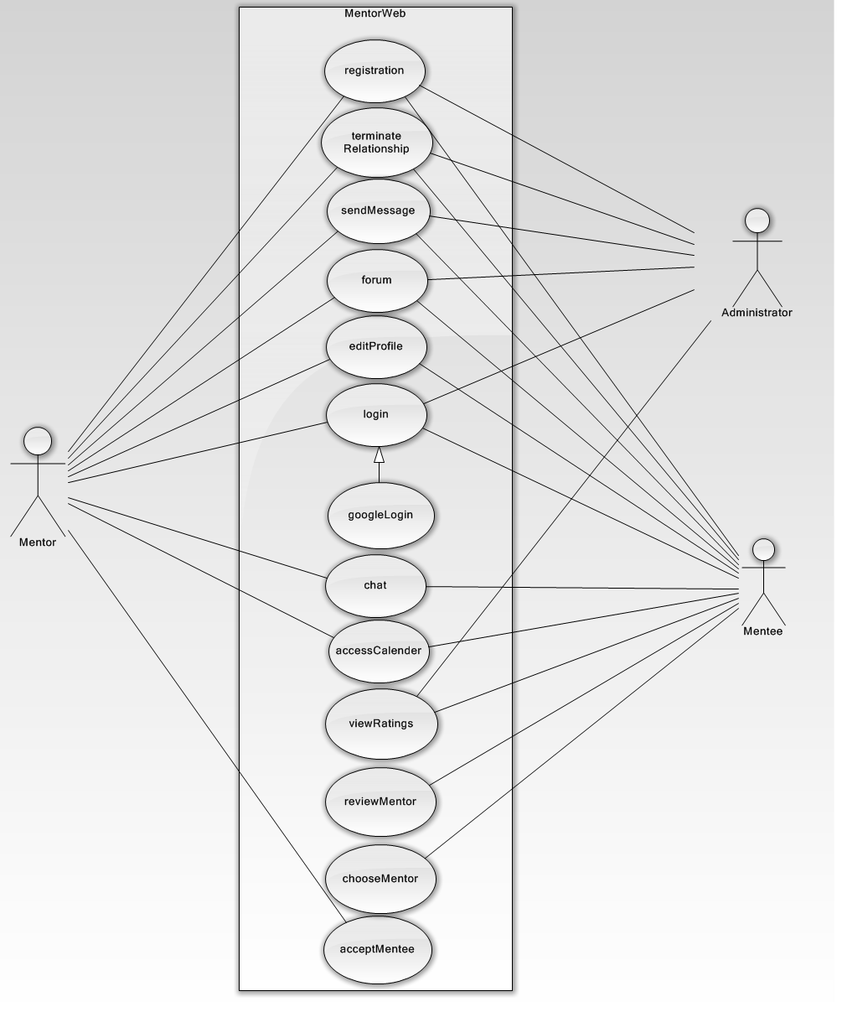

## 3.4.3 Object Model

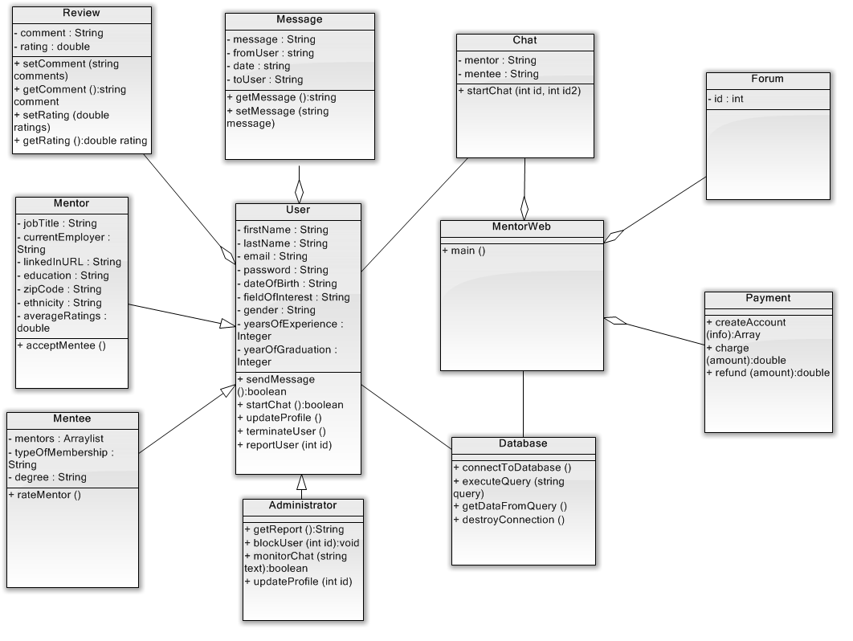

## 3.4.4 Dynamic Model

### 3.4.4.1 Sequence Diagrams

#### 3.4.4.1-1 Login Mentee

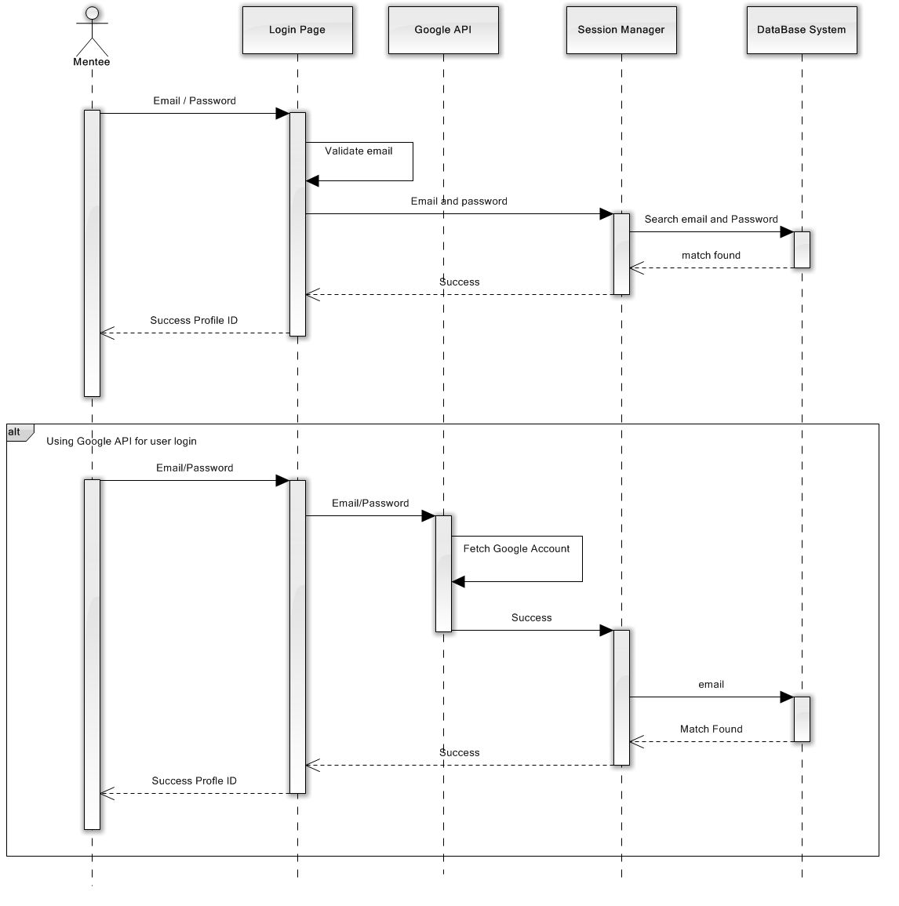

#### 3.4.4.1-2 Login Mentor

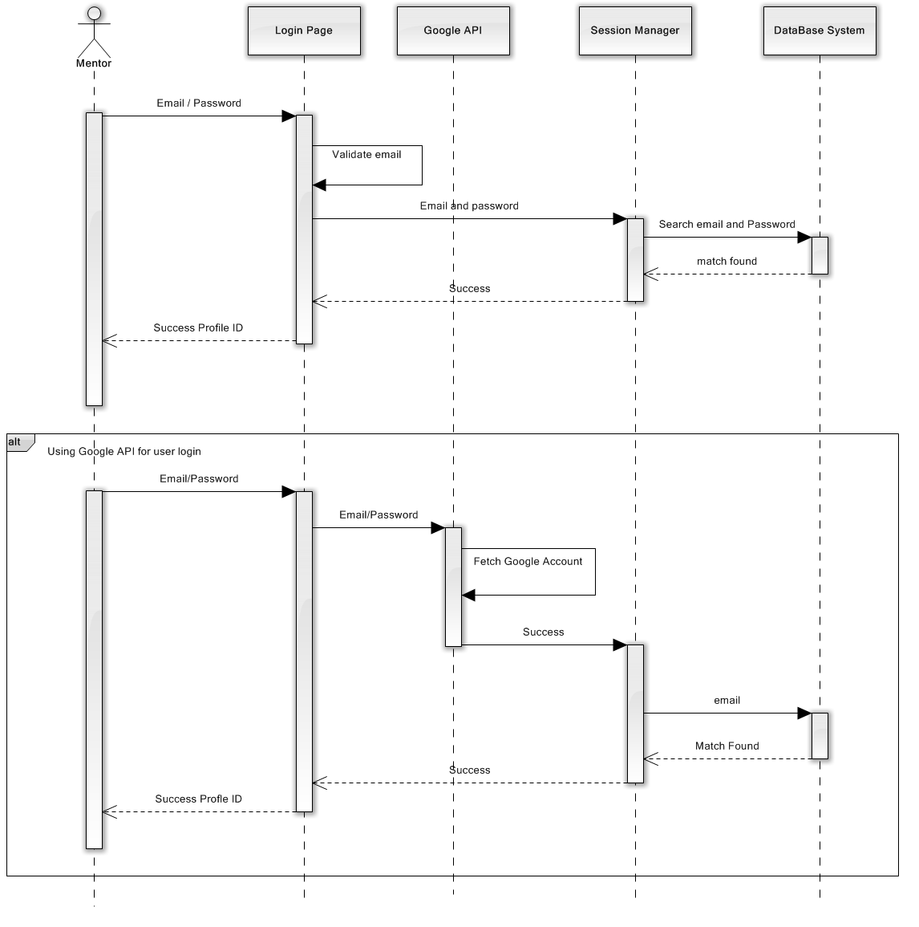

#### 3.4.4.1-3 Register Mentee

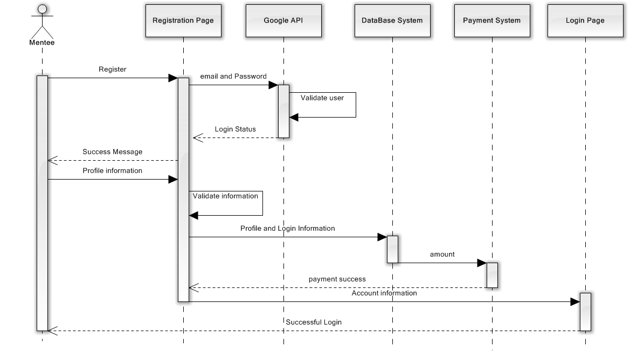

#### 3.4.4.1-4 Register Mentor

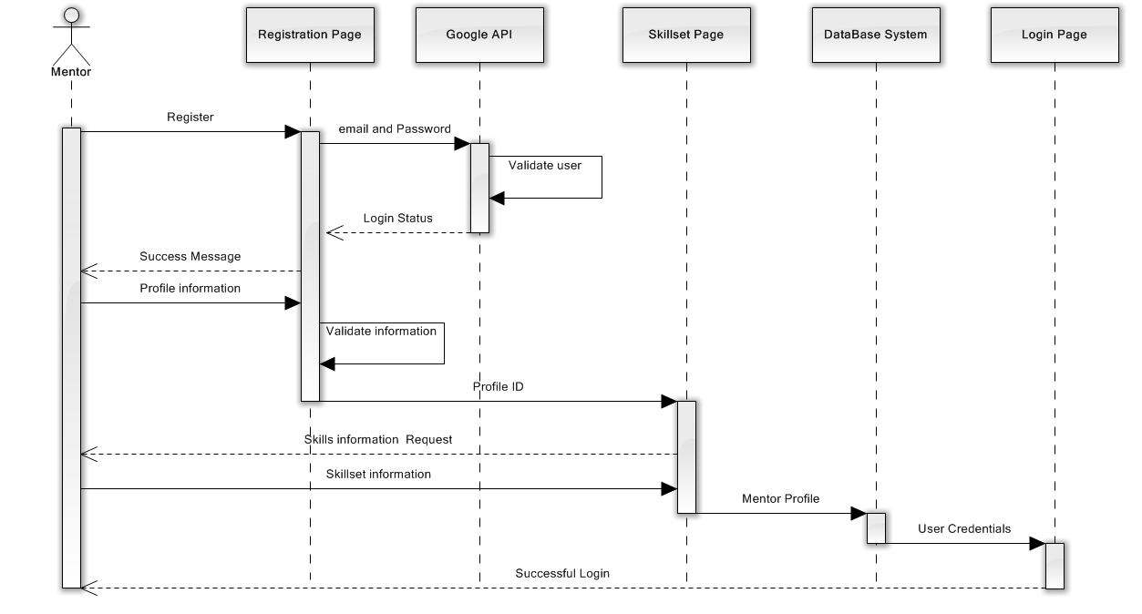

#### 3.4.4.1-5 Register Mentee

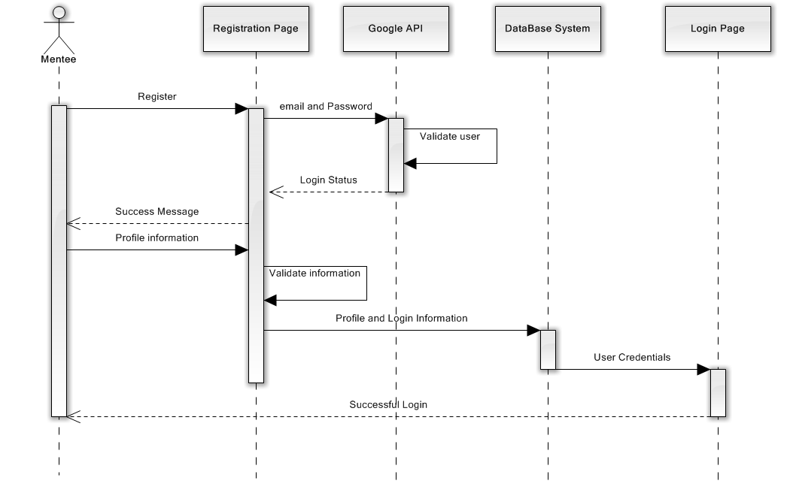

#### 3.4.4.1-6 Register Mentor



#### 3.4.4.1-7 Rate Mentor

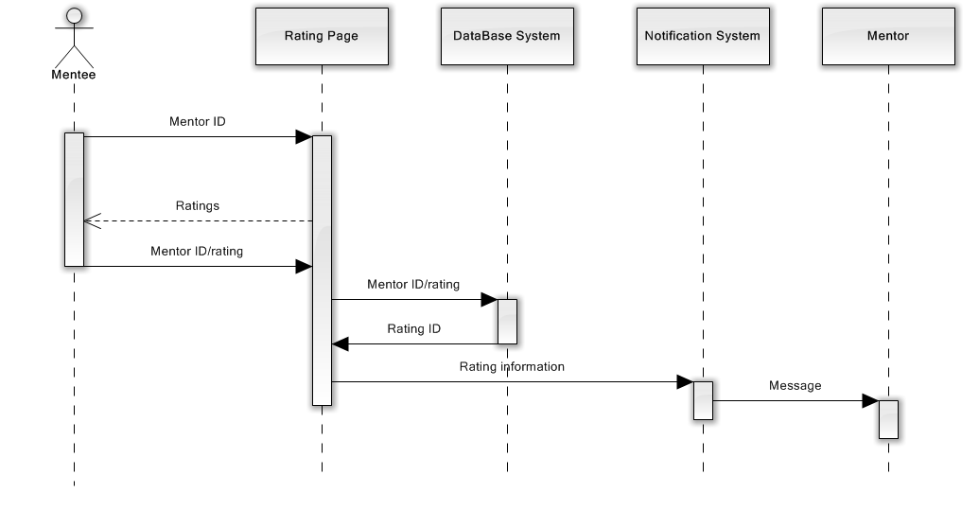

#### 3.4.4.1-8 Send Message

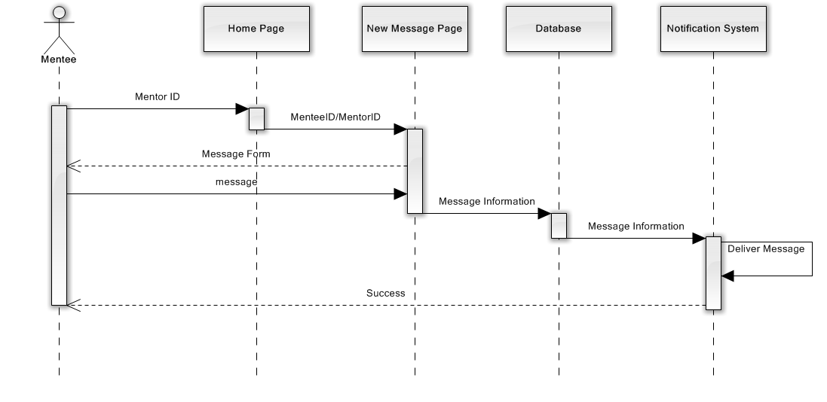

#### 3.4.4.1-9 Start Chat

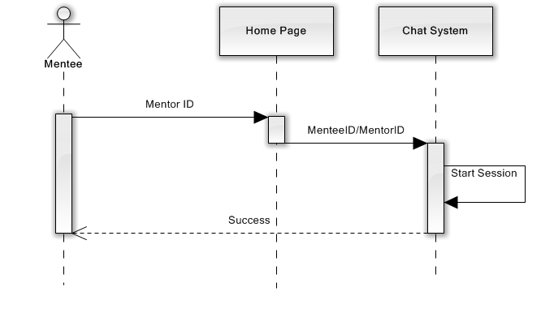

#### 3.4.4.1-9 Update Profile Mentee

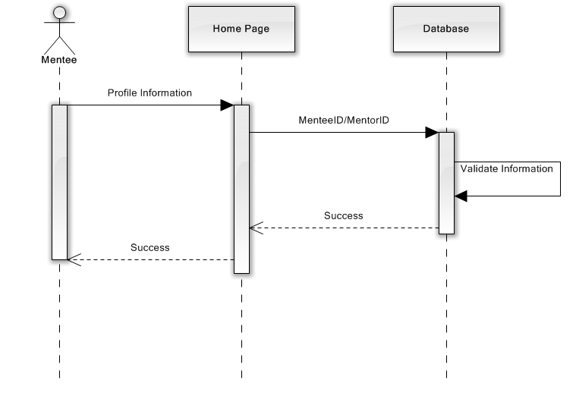

#### 3.4.4.1-10 Choose a mentor

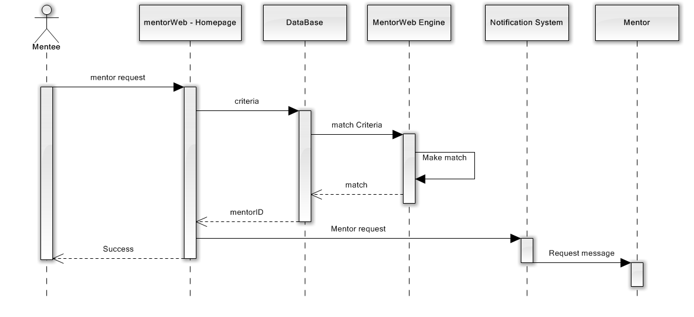

#### 3.4.4.1-11 Review a mentor

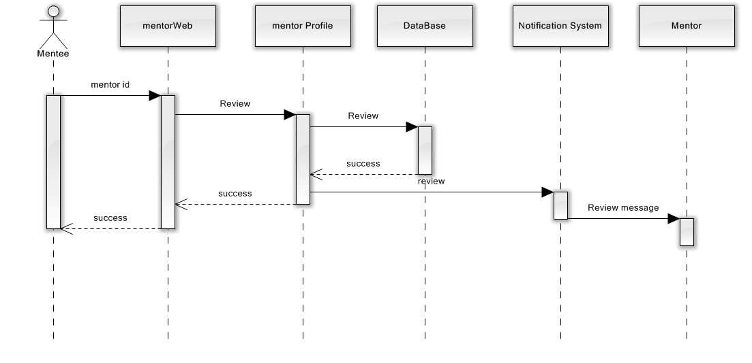

### 3.4.4.2 State Machine Diagrams

#### 3.4.4.2-1 User State

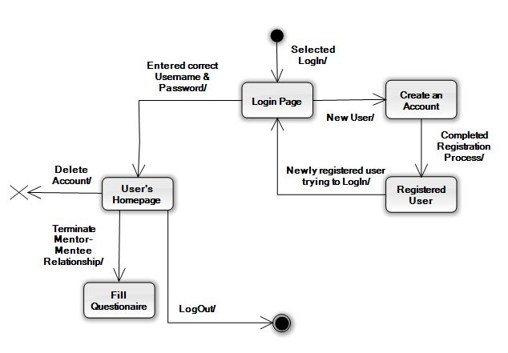

### 3.4.4.3 Activity Diagrams

#### 3.4.4.3-1 Login

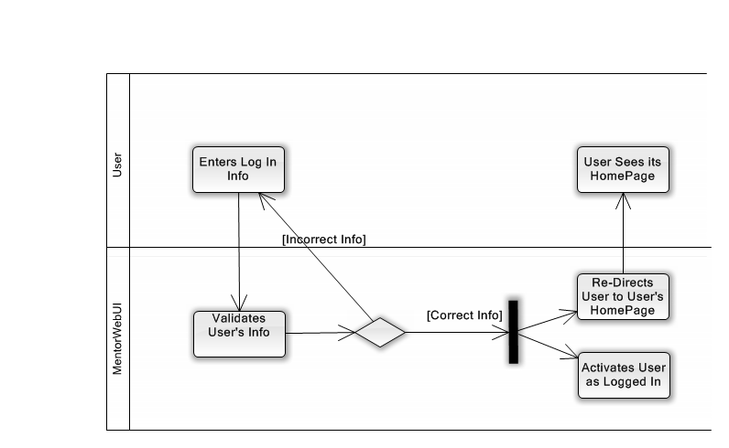

#### 3.4.4.3-2 Mentor mentee Matching

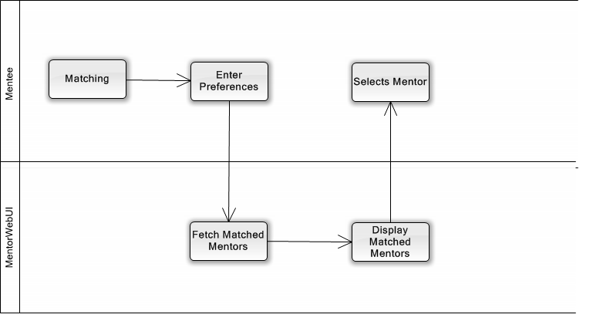

#### 3.4.4.3-3 Messages

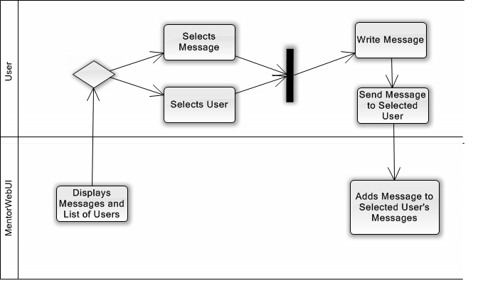

#### 3.4.4.3-4 Registration

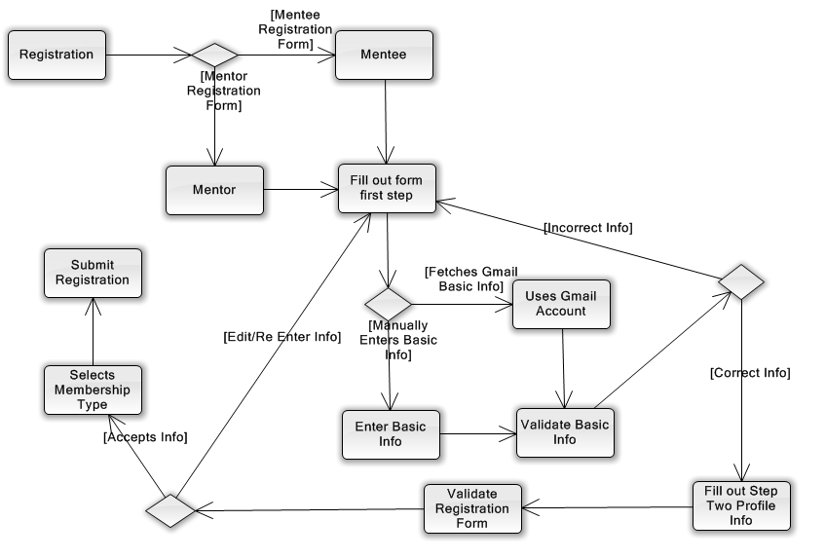

#### 3.4.4.3-4 Terminate Relationship

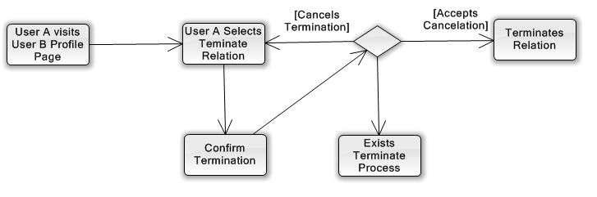

## 3.4.5 User Interface

### 3.4.5.1 Screen Mockups

#### 3.4.5.1-1 Mentee Home Page

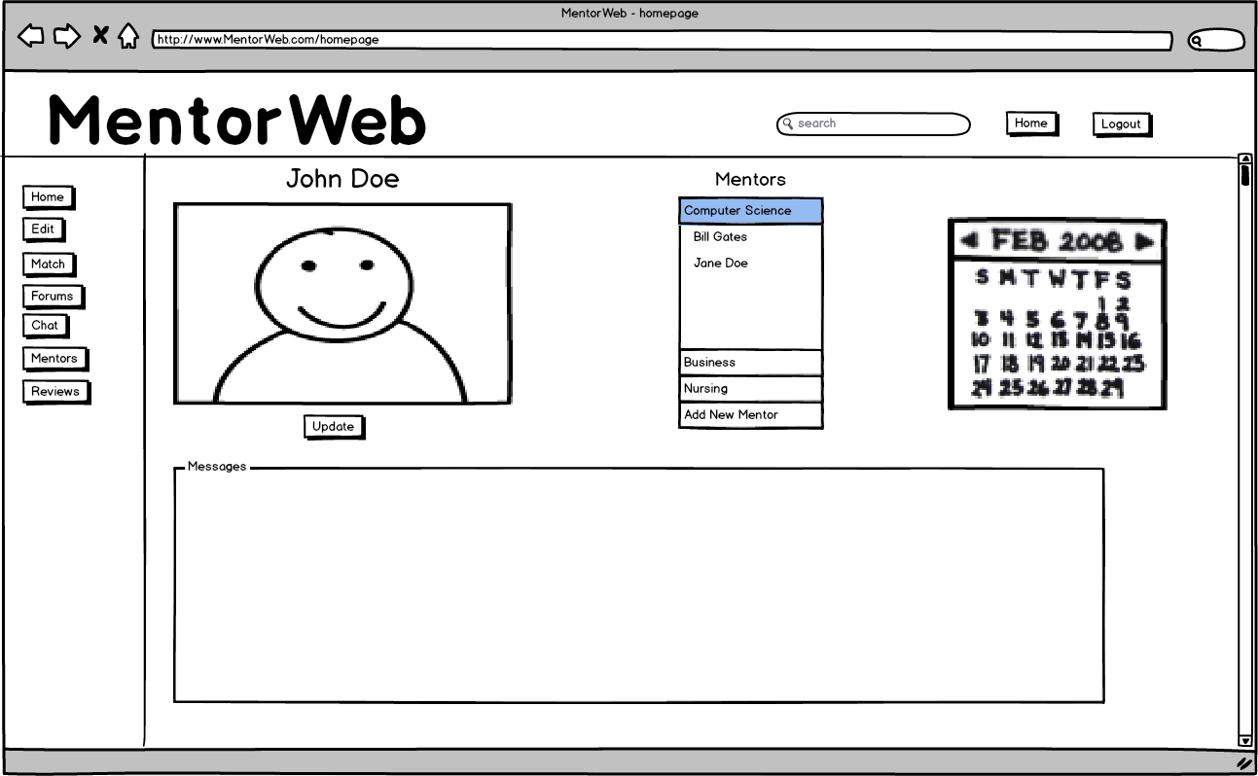

#### 3.4.5.1-2 Mentor Profile

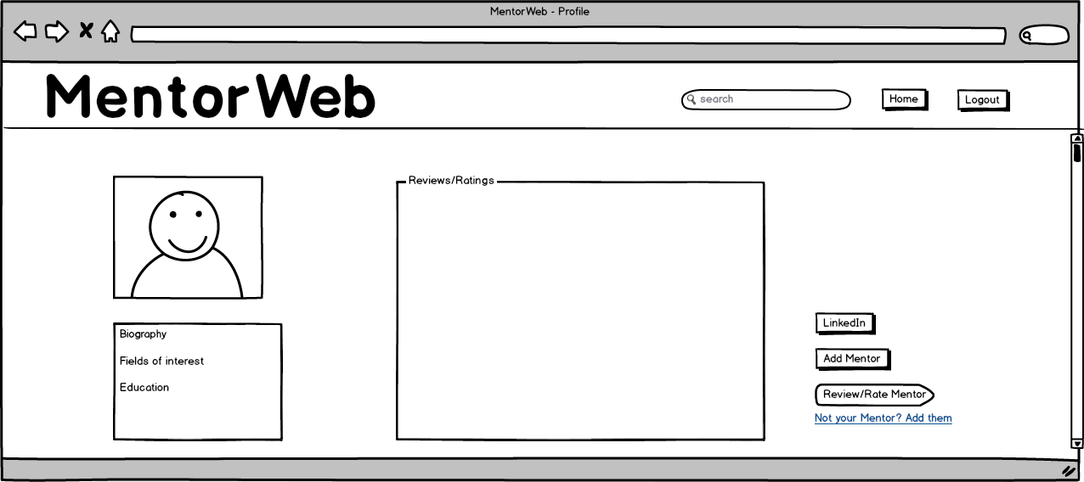

#### 3.4.5.1-3 Mentor Registration

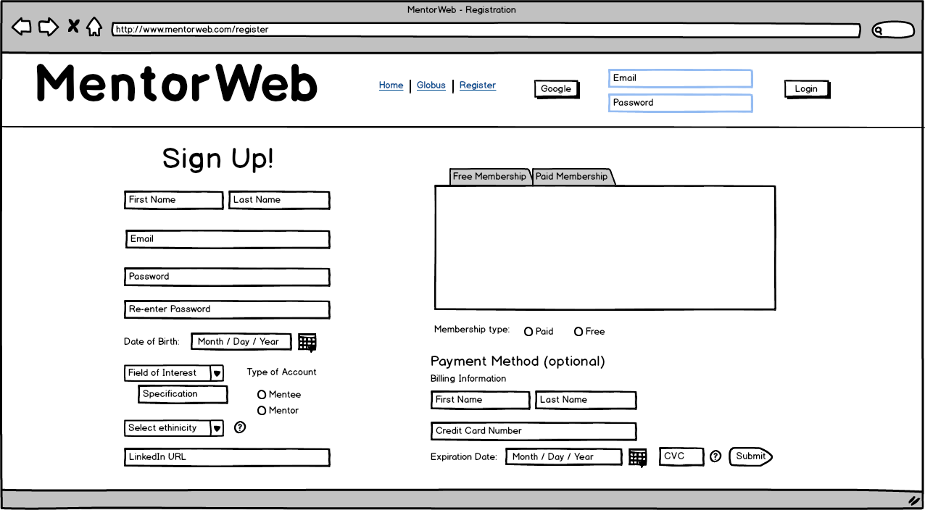

#### 3.4.5.1-4 Mentor Review

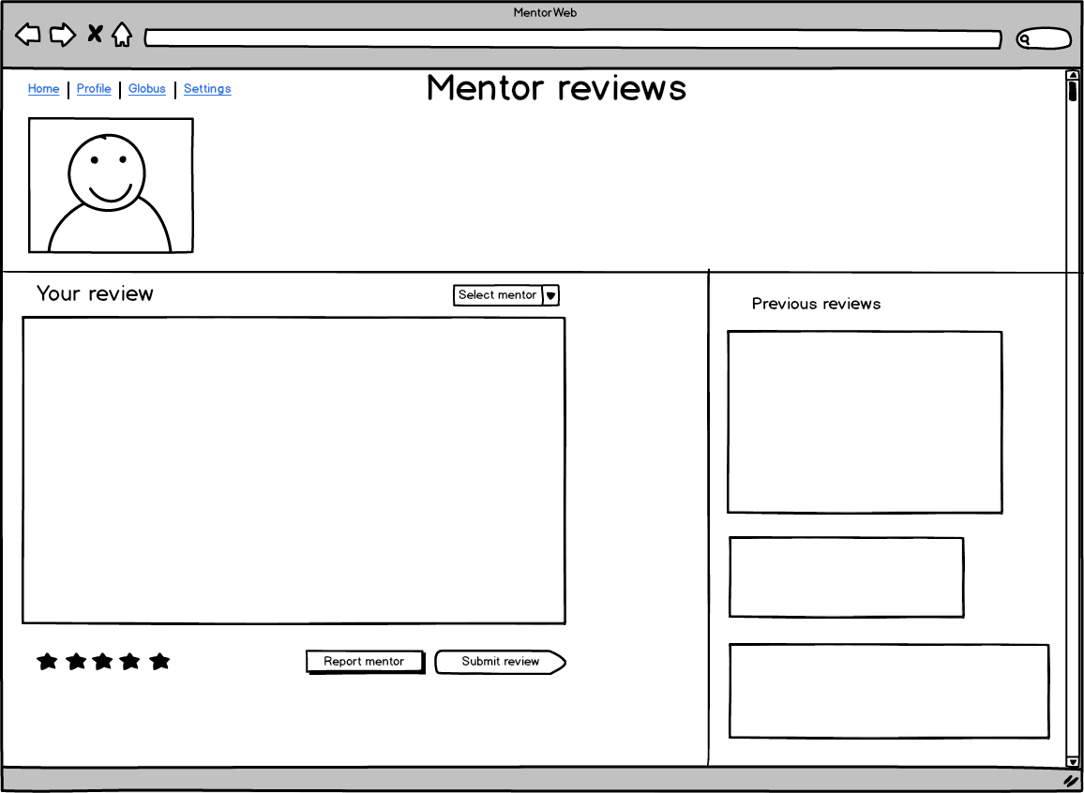

#### 3.4.5.1-5 Chat

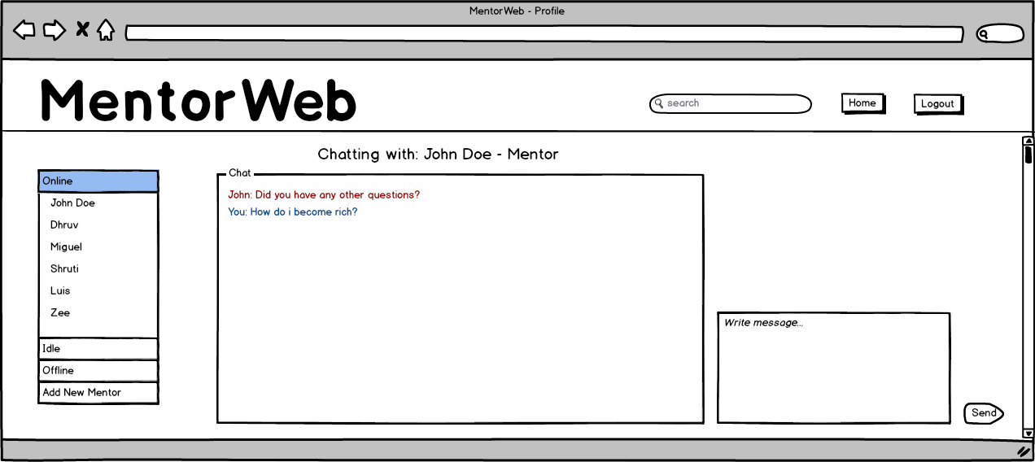

### 3.4.5.2 Navigational Paths

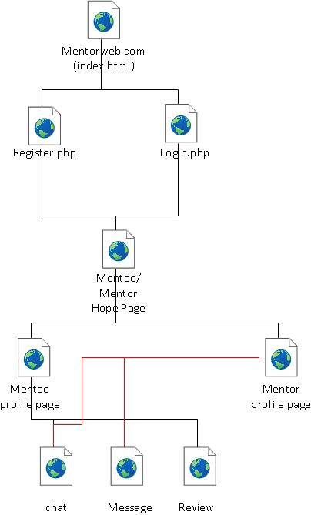

4. Glossary

|  |  |
| --- | --- |
| **Application** | A programming library that may include specification for routines, data |
| **Programming Interface (API)** | Structures, object class, and variables. |
| **Database** | Collection of data organized as a set of formally described tables from which data can be accessed easily. |
| **Google App engine** | A cloud computing platform for developing hosted web applications in the Google managed cloud |
| **Graphical User Interface** | A human-computer interface that uses windows, icons and menus which can be manipulated using a mouse or keyboard |
| **Integrated Development Environment (IDE)** | A software application that provides comprehensive facilities to computer programmers for software development |
| **Java (Language)** | Java is an object-oriented programming language originally developed by James Gosling at Sun Microsystems |
| **Mentor-mentee** | Relationship between users to facilitate mentorship. |
| **Terminator** | User that takes the initiative to end mentor-mentee relationship. |

5. Appendices

# 5.1 Hardware Requirements

5.1.1 Clients

The MentorWeb system will require only basic hardware in order to provide its services. An internet connection is required, as MentorWeb is a web-application that runs within a browser. The supported browsers for MentorWeb will be Mozilla Firefox and Internet Explorer. All other services, such as a chat client system, a mentor-mentee matching system, and forums are provided by MentorWeb. The system can also be accessed by any device that has an internet connection, including tablets, and mobile phones. Finally, a Java installation is recommended as some features of MentorWeb will be using Java.

5.1.2 Server

MentorWeb will use Google’s cloud services (Google App Engine).

# 5.2 Project Plan

The intended, but tentative project plan for the schedule and completion of the MentorWeb system is shown below.

|  |  |  |  |  |  |
| --- | --- | --- | --- | --- | --- |
| Action | Resources | Description | Required | Due Date | % Complete |
| 1 | All team members | Functional and Nonfunctional system requirements definition | N/A | 02/24 | 100% |
| 2 | All members | System Models design | 1 | 02/28 | 100% |
| 2 | Shruti, Dhruv, Miguel | Navigational Paths and Screen Mockups | 2 | 03/02 | 100% |
| 4 | Miguel, Luis, Zohaib | Proof of Concept of Google App Engine as a viable technology for the project | N/A | 03/02 | 5% |
| 5 | All team members | Modularize the system into 3 modules (User, Admin, Communications) | 1,4 | 03/05 | 0% |
| 6 | All team members | Start Mapping models to Code | 5 | 04/2 | 0% |
| 7 | TBA | Testing Phase 1 | 6 | 04/09 | 0% |
| 8 | TBA | Alpha Testing | 7 | 04/11 | 0% |
| 9 | TBA | Beta Testing | 8 | 04/18 | 0% |
| 10 | TBA | Pre – release | 9 | 04/25 | 0% |
| 11 | TBA | Project Release | 10 | 04/30 | 0% |
| 12 | All team members | Project presentation | 12 | 05/07 | 0% |

# 5.3 Team Globus staffing

Team Globus’s staffing will include five people, listed below.

1. Luis Barreto - (Team leader/Project manager)
2. Shruti Padmanabhan
3. Zohaib Khan
4. Dhruv Mevada
5. Miguel Gonzalez

Every staff member will working on each aspect of the project, from software design, implementation, testing, delivery, and presentation.

# 5.4 Work log

Team Globus’ work log is shown below, and shows the days that the team has met, in bold.

For each day, there is a description of what was accomplished during the meeting, as well as other necessary parameters such as meeting type, meeting minutes, and bullet points of completed tasks.

## Thursday, 2/14/13

1. The team met with the professor to discuss the beginnings of the project, its organization, and other aspects.
2. All members of the team met to discuss the preliminary questions, and the upcoming meeting with the professor.
3. The team determined which questions should be eliminated from the initial list.
4. Miguel scribed for the meeting, and it was determined that Dhruv would be the next host.
5. The team met from 4:05-4:55, 50 minutes.
6. Meeting type: Face-to- face, medium-length.
7. The team also met with the professor from 5:00 - 5:15, 15 minutes
8. Meeting type: Stand-up, short meeting, informal.
9. For Thursday, Shruti created a rough, graphical layout of MentorWeb.
10. Miguel typed up meeting minutes, uploaded it to Google docs, and sent a copy to the professor.

## Tuesday, 2/19/13

1. The team met to discuss functional requirements and formulate new ones.
2. Zohaib and Dhruv went through the first 36 questions from the list, and created functional requirements, and separated them based on category.
3. Miguel and Shruti also did the same with another part of the questions.
4. The team met from 4:10 - 5:45, 95 minutes.
5. Meeting type: face-to-face, long, working session.

## Wednesday, 2/20/13

1. All members were present, and the team made significant progress on the requirements, and divided up the requirements into their respective categories.
2. Zohaib, Miguel and Dhruv worked on extracting more requirements from questions, and continued their work from Tuesday.
3. Miguel and Dhruv further continued the work, and had a video-chat with Luis on new tasks to determine what needs to be completed.
4. Shruti and Dhruv further had a general discussion on the project scope, requirements, and decided to create further new functional requirements from the team’s design perspective.
5. The team met from 11:30-2:50, 200 minutes.
6. Meeting type: face-to-face, virtual, long working session.

## Friday, 2/22/13

1. All members met virtually on Google hangouts, to discuss functional/non-functional requirements, and work distribution.
2. All members worked on functional requirements by changing pre-existing requirements from during the week, and adding new ones to provide additional features.
3. In the second hour, Zohaib and Dhruv split into a different hangout session, to finish non-functional requirements.
4. Zohaib and Dhruv rejoined the original hangout in the last hour to discuss work distribution of the upcoming SRS document.
5. Meeting type: virtual, long working session.
6. The team met from 7:00PM - 10:00PM, 180 minutes

## Thursday, 2/28/13

1. All members met at the SCE club room to work on use cases, and draw a mock-up of the GUI.  
   After the meeting, the entire team met with the professor to discuss both versions of the Requirements Analysis Document, proof of concept, and current status of the team’s tasks.
2. Zohaib and Dhruv worked on the use cases for the mentor module.
3. Shruti and Luis worked on the uses cases for the mentee module.
4. Luis and Miguel worked on the uses cases for the administration module.
5. All members helped to make a rough sketch of the GUI.
6. Meeting type: face-to-face, medium-length.
7. The team from 4:00PM - 4:55PM, 55 minutes.
8. Dhruv was the host and Zohaib was the scribe for the meeting with the professor.
9. The team discussed the RAD, proof of concept, and current tasks.
10. The professor suggested that scenarios should be done first.
11. Meeting type: Face-to-face, informal, short.
12. The team met with the professor from 5:05PM - 5:20PM, 15 minutes.

## Sunday, 3/3/13

1. Shruti, Luis, and Dhruv met virtually to discuss scenarios, use cases, and system models.
2. Luis made the decision that Software Ideas Modeler would be used for creating system models.
3. The team divided up the remaining scenarios and use cases.
4. Meeting type: Virtual, medium-length.
5. The team met from 8:55PM-9:38PM, 43 minutes.

## Friday, 3/8/13

1. All team members met virtually on Google hangouts to discuss and make system models.
2. Luis divided the models accordingly.
3. Dhruv and Zohaib worked on the user-interface and the screen mock-ups.
4. Shruti and Miguel worked on the state machine diagrams and activity diagrams.
5. The entire team worked on creating the class diagrams, and contributed to writing the use cases descriptions, models, and scenarios.
6. Each member of the team also revised their respective parts from the first version of the Requirements Analysis Document, to be updated for version 2.
7. Meeting type: Virtual, long meeting
8. The team met from 7:30-9:30, 120 minutes.

## Saturday, 3/9/13

1. All team members met virtually on Google hangouts to discuss system models, and progress.
2. Scenarios were finished, and use cases were finalized.
3. Dhruv and Zohaib split up the mock-ups.
4. The entire team worked on the class diagrams.
5. Meeting type: virtual, medium-length meeting
6. The team met from 8:30PM - 9:30PM, 60 minutes

## Sunday, 3/10/13

1. All team members met virtually on Google hangouts to finalize system models, and complete class diagram.
2. Dhruv and Zohaib uploaded the final mock-ups to Google Drive.
3. Shruti uploaded the state machine diagram, and Miguel finished the activity diagram.
4. Luis reviewed the whole document, and every team member did their respective revisions from RAD version 1.
5. The entire team discussed class diagram attributes and operations.
6. Meeting type: virtual, long meeting.
7. The team met from 6PM - 9PM, 180 minutes.

## Thursday, 3/14/13

All team members met with the professor to discuss current progress.

* Dhruv was the scribe, and luis was the host.
* Discussed the SDD deadline, and specifics such as the technology that would be used.
* Meeting type: face-to-face, short, sitting down meeting.
* The team met from 5:00 PM - 5:15 PM, 15 minutes

## Thursday, 4/4/13

All team members met with the professor to discuss the upcoming SDD, and subsystem decomposition. After receiving feedback from the professor, the team split up the work for the SDD accordingly. A summary of the tasks that were discussed during the meeting, and completed afterwards is listed below.

* Zohaib worked on Part 1 (Introduction) of the SSD.
* Dhruv and Shruti worked together on parts 2 and 3.1,3.2,3.3,3.4 (Current software architecture, and proposed software architecture), respectively.
* Dhruv made a UML component model to accompany the subsystem decomposition section. Dhruv also created some diagrams to depict the relationship between cloud platform, and the hardware.
* Shruti designed the MVC pattern, and wrote the general description of the hardware-software mapping, subsystem decomposition, as well as the persistent data management.
* Dhruv added onto 3.2,3.3, and 3.4, also completed 3.1 (overview)
* Luis worked on 3.5,3.6,3.7, and the first half of section 4.  Luis also created the UML deployment diagram that was necessary for Section 3
* Dhruv updated and finished the second half of section 4 (Glossary).
* Meeting type: face-to-face
* The team met from: 5:00 PM - 5:15 PM, 15 minutes.

## Sunday 4/14/13

All team members met for a coding meeting, to develop MentorWeb.

* Miguel started designing the front end of the website.
* Shruti, Luis, Dhruv and Zohaib continued further understanding code, and data management.
* Luis and Miguel finished the Registration subsystem.
* Shruti, Zohaib, and Dhruv worked on saving data to the database, and using the Jinja2 template.
* Work was split up, Dhruv would focus on the Message subsystem, Shruti would focus on the administrator and database subsystem, and Zohaib would continue working on the chat subsystem.
* Luis and Miguel would continue working on the Login subsystem.
* Meeting type: face-to-face, long, coding
* The team met from 1:30 PM - 5:00 PM, 210 minutes.

## Thursday 4/18/13

Miguel, Dhruv, Zohaib, and Shruti met to continue programming of the Message subsystem for MentorWeb.

* Dhruv created subtasks for the Message subsystem, and started implementing the sender and receiver functionality.
* Shruti, Zohaib, and Miguel helped Dhruv in fetching the proper info from the datastore.
* Meeting type: face-to-face, medium, coding.
* The team met from 4:00 PM - 4:55 PM, 55 minutes.

## Thursday 4/18/13

All team members met with the professor to discuss progress and ask questions about upcoming documentation, and final due date.

* Zohaib was the host, and Luis was the scribe.
* Meeting type: face-to-face, short, sitting down meeting
* The team met from 5:00 PM - 5:15 PM, 15 minutes.

## Sunday 4/28/13

All team members met for a coding meeting, to continue development of MentorWeb.

* Luis and Dhruv worked on the chatting subsystem.
* Shruti, Zohaib, and Luis worked on completing the message system, and developing other parts of the website, such as the matching algorithm, responsible for matching mentors with mentees.
* Meeting type: Face-to-face, long, coding
* The team met from 10AM - 2PM, 240 minutes.

6. Index

Application 3, 9

Database 9, 10

Environment 3, 10

Google App Engine 9, 10

Graphical User Interface 9, 10

Interface 9, 10

Java 9, 10

Mentor-mentee 3, 5, 7, 10